**Resource Group:**

**List of Resources:**

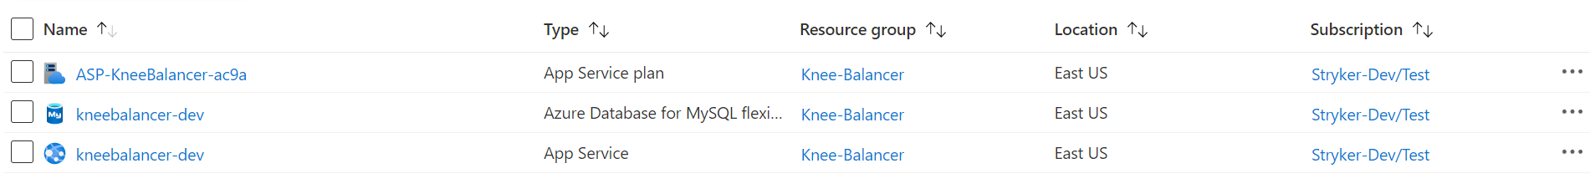

**Unsecure resource:**



[Security Assessment.docx](Security%20Assessment.docx)